
Arden University – Berlin


Data Visualisation

COM7021


Data Visualisation Portfolio


24169956


Prof. Ahmed Hassan


3,267

Table of Contents
Introduction 3
1.1 What the board needs to know 3
1.2 Aim of this report 3
Task 1: The Python investigation 4
2.1 The Dataset 4
2.2 Data Preprocessing 5
2.3 Exploratory Data Analysis (EDA) 6
2.4 The Eight Charts 8
2.4.1 Chart 1: City performance overview (geo map) 8
2.4.2 Chart 2: Revenue sunburst 9
2.4.3 Chart 3: Cost heatmap by year 10
2.4.4 Chart 4: Revenue radar by city 10
2.4.5 Chart 5: Profit margin (%) by year 11
2.4.6 Chart 6: Units sold vs profit 12
2.4.7 Chart 7: Revenue treemap 12
2.4.8 Chart 8: Revenue Sankey flow 13
2.5 The dashboard 13
2.6 What the data tells us 16
Task 2: A Critical Reflection 17
3.1 Justification of chart choices 17
3.2 Designing the dashboard for a mixed audience 18
3.3 Strengths and limitations of the approach 19
3.4 Recommendations for the board 19
4 Tableau as a Comparative Dashboard 20
4.1 Why I also built a Tableau version 20
4.2 How Tableau differs from the Python dashboard 21
5 Conclusion 23
References 24
Appendices 25

Introduction
The company European Bakery operates five retail locations around Europe: London, Paris, Bonn, Seville, and Napoli. The board now possesses six years' worth of sales data (2000 to 2005). The company sells a limited selection of confections. The board's task is straightforward: identify the towns and goods that generate the most profit, and inform the board if the information warrants closing any of the stores.

What the board needs to know
This paper is intended for a diverse audience. While some board members prefer a chart that provides the answer in a matter of seconds, others are content with raw numbers. I must make something that works for both of them. I'm specifically responding to two questions: how each store's location influences profitability and how the kind of confectionery influences it.

Aim of this report
The goal is to transform a raw Excel file containing 1,001 sales records into something the board can use. I created the visualizations in Plotly and completed the data processing in Python using Pandas before combining them into a single interactive dashboard with global filters and KPI tiles.

Task 1: The Python investigation

The Dataset
There are seven columns and 1,001 rows in the Excel file. With the date, city, confectionery item, units sold, revenue, cost, and profit (all expressed in pounds sterling), each row represents a single sale. The data covers six whole years, from January 2, 2000, to December 28, 2005. There are five cities and six goods after cleaning. The complete summary is provided in Table 2.1.
Item | Value
Total rows | 1,001
Columns | 7 (Date, City, Confectionery, Units Sold, Revenue (£), Cost (£), Profit (£))
Date range | 2 January 2000 – 28 December 2005
Cities (5) | Bonn, London, Napoli, Paris, Seville
Products before cleaning | 8 categories
Products after cleaning | 6 categories
Currency | Pound sterling (£)
File format | Excel (.xlsx)
Source | Data Visualisation - COM7021 - [4566] Bakery- supporting document.xlsx
Table 2.1: Dataset Overview

Data Preprocessing
During the initial inspection, two problems were discovered. Inconsistent naming inside the Confectionery column was the first. "Chocolate Chunk" only featured sixteen times, but "Choclate Chunk" appeared 130 times. There were 82 instances of "caramel nut" and 67 instances of "caramel nut". Due to a spelling error and a case variation, the same product was being divided into two categories. Using a modest mapping dictionary that reduced eight notional categories to the six actual ones, I was able to rectify both (Table 2.2.1).
Confectionary Item | Original Count | Action | Final Name | Final Count
Caramel | 345 | Kept | Caramel | 345
Choclate Chunk | 130 | Typo fixed | Chocolate Chunk | 146 (130+16)
Biscuit Nut | 125 | Kept | Biscuit Nut | 125
Biscuit | 124 | Kept | Biscuit | 124
Plain | 112 | Kept | Plain | 112
Caramel nut | 82 | Merged into Caramel Nut | Caramel Nut | 149 (82 + 67)
Caramel Nut | 67 | Merged | (merged above) | —
Chocolate Chunk | 16 | Merged | (merged above) | —
Total Categories | 8 |  |  | 6
Table 2.2.1: Confectionery Name Cleanup
The second problem was that four numerical columns had 26 missing values. Since Paris and London have various price points and a worldwide median would have obscured that, I filled them in with the median value for each column, grouped by city. After cleaning, Table 2.2.2 verifies that no data remains missing.

Column | Missing values before cleaning | Missing values after cleaning
Units Sold | 5 | 0
Revenue (£) | 9 | 0
Cost (£) | 9 | 0
Profit (£) | 3 | 0
Total | 26 | 0
Table 2.2.2: Missing values per column

To illustrate quarterly and annual trends on the time-series charts, I then extracted three additional date attributes (Year, Month, and YearStr).

Exploratory Data Analysis (EDA)
After cleaning, I performed descriptive statistics on each of the four numerical columns (Table 2.3.1). The biggest single-transaction profit is £13,479, the median is £3,461, and the mean profit per transaction is £4,011. The distribution is slightly biased to the right, indicating that the company relies more on consistent mid-sized sales than a small number of major clients.

Statistics | Units Sold | Revenue (£) | Cost (£) | Profit (£)
count | 1001.00 | 1001.00 | 1001.0 | 1001.00
mean | 1632.63 | 6842.14 | 2817.0 | 4011.70
std | 874.27 | 4678.85 | 2065.0 | 2644.21
min | 200.00 | 200.00 | 40.0 | 160.00
25% | 941.00 | 3010.00 | 1228.5 | 1873.60
50% | 1531.00 | 5984.00 | 2459.6 | 3460.80
75% | 2296.00 | 9495.00 | 3908.0 | 5445.00
max | 4493.00 | 23988.00 | 10994.5 | 13479.00
Table 2.3.1: Descriptive statistics

The first response to the board's query was to aggregate profit by city (Table 2.3.2). With a profit of £936,914 over the last six years, Paris leads, followed closely by Napoli with £913,679. Despite having the lowest total profit of £695,061, London is nevertheless profitable.

Rank | City | Total Profit (£) | Share %
1 | Paris | £936,914.20 | 23.3%
2 | Napoli | £913,678.70 | 22.8%
3 | Seville | £746,995.00 | 18.6%
4 | Bonn | £723,059.50 | 18.0%
5 | London | £695,061.12 | 17.3%
Total | £4,015,708.52 | 100%
Table 2.3.2: Total profit by city (ranked)

As shown in profit by confectionery (Table 2.3.3), Caramel alone generates £1.64 million in profit, which is more than the combined earnings of the following two goods. With just £148,034, Plain is at the bottom.
Rank | Product | Total Profit (£) | Share %
1 | Caramel | £1,643,008.38 | 40.9%
2 | Caramel Nut | £712,104.75 | 17.7%
3 | Biscuit | £605,680.80 | 15.1%
4 | Biscuit Nut | £515,297.50 | 12.8%
5 | Chocolate Chunk | £391,583.50 | 9.8%
6 | Plain | £148,033.60 | 3.7%

The Eight Charts
To address various aspects of the board's topic, I created eight Plotly charts. Every interactive chart (hover, filter, click) has a uniform colour scheme so that a city's colour is consistent across the report.

Chart 1: City performance overview (geo map)
The five cities are depicted on a map of Europe in the first chart. The size of each marker is based on the city's revenue; the larger the bubble, the higher the percentage.
Total sales and profit margin by city are displayed in two horizontal bar charts on the right. In a single glance, the map provides the spatial answer: London and Bonn are in the upper third of the continent, whereas most business is in Paris and Napoli.
Above the map, a live KPI panel displays total revenue, total profit, average margin, and units sold for the chosen cities and years.
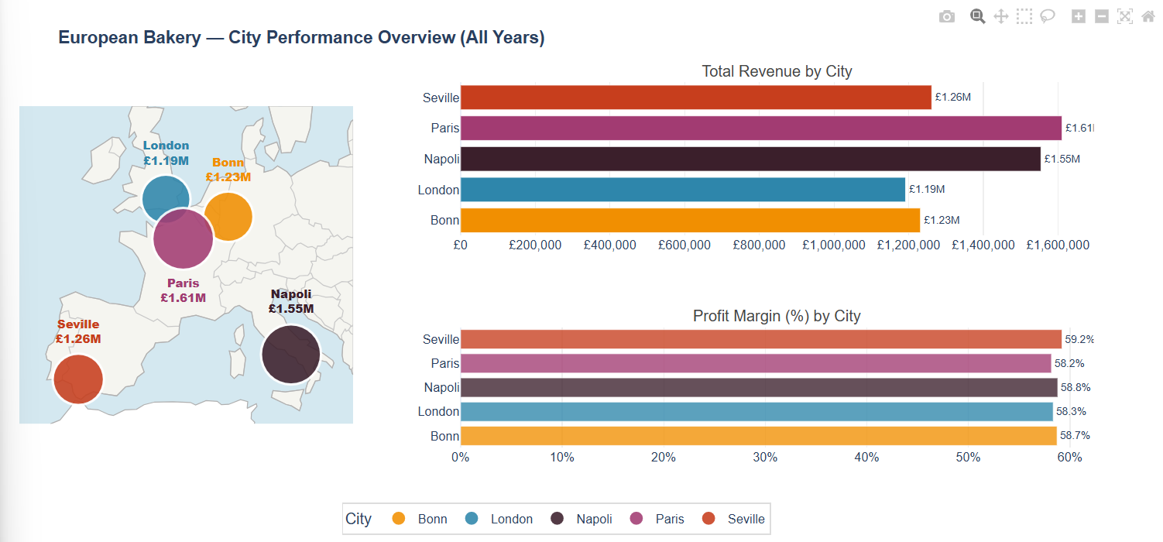
Figure 2.4.1: City performance overview

Chart 2: Revenue sunburst
With the city in the inner ring and sweets in the outer ring, the sunburst divides revenue into a two-level hierarchy. The outer ring reveals a distinct picture, with Paris, Napoli, Seville, Bonn, and London occupying between 17% and 24% of the inner ring. One slice dominates the outer ring of London: 64% of the city's income comes from caramel. The distribution of the six products is more uniform in every other city.
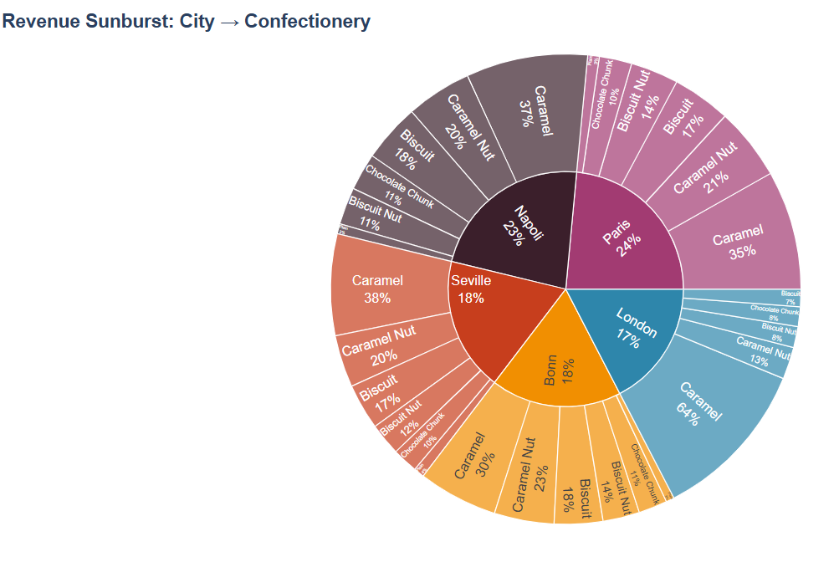
Figure 2.4.2: Revenue sunburst, City to Confectionery

Chart 3: Cost heatmap by year
This heatmap displays the year on the horizontal axis, confectionary on the vertical, and the colour intensity for the overall cost. Every year, Caramel has the brightest band at the top, matching the profit ranking. The dark, thin row at the bottom is plain. The finance staff can quickly identify any cost increases for a certain product each year.

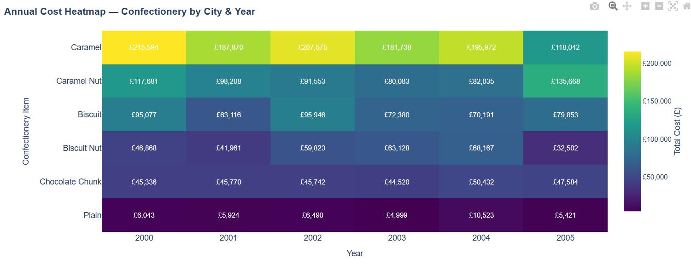
Figure 2.4.3: Annual cost heatmap by confectionery and year

Chart 4: Revenue radar by city
Each city is represented by a single polygon in the radar plot, with the six products on the angle axis and revenue on the radius. A rounded polygon is the result of a balanced product combination.
London's polygon, which depicts the same reliance as the sunburst but in a different form, is oriented sharply in the direction of Caramel. Out of the five cities, Paris and Napoli have the most balanced polygons.

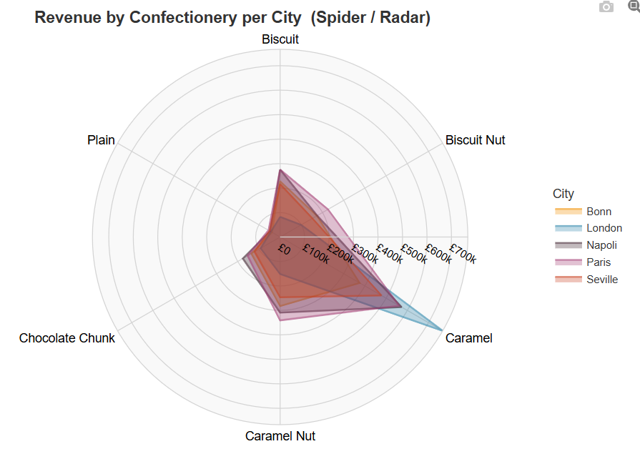
Figure 2.4.4: Revenue radar by city and confectionery

Chart 5: Profit margin (%) by year
Profit margin by city and year (profit divided by revenue). Over the course of the six years, all five cities fall between 57% and 60%. No city is clearly performing below expectations in terms of margin. This is significant for the closure question since it indicates that London's poor total profit is a volume issue rather than a pricing or cost issue.
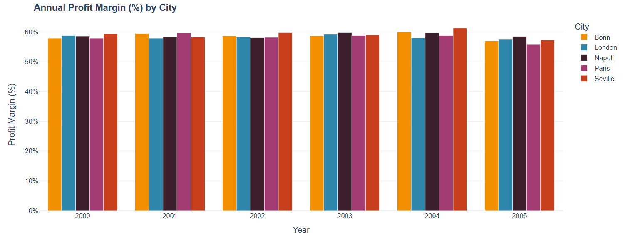
Figure 2.4.5: Annual profit margin (%) by city

Chart 6: Units sold vs profit
A scatter of each transaction, coloured by city, with profit on the y-axis and units sold on the x-axis. Because of the nearly perfect linearity of the connection, the profit per unit is rather stable between cities. No city is selling a large number of units at a low profit, and there are no clear outliers.
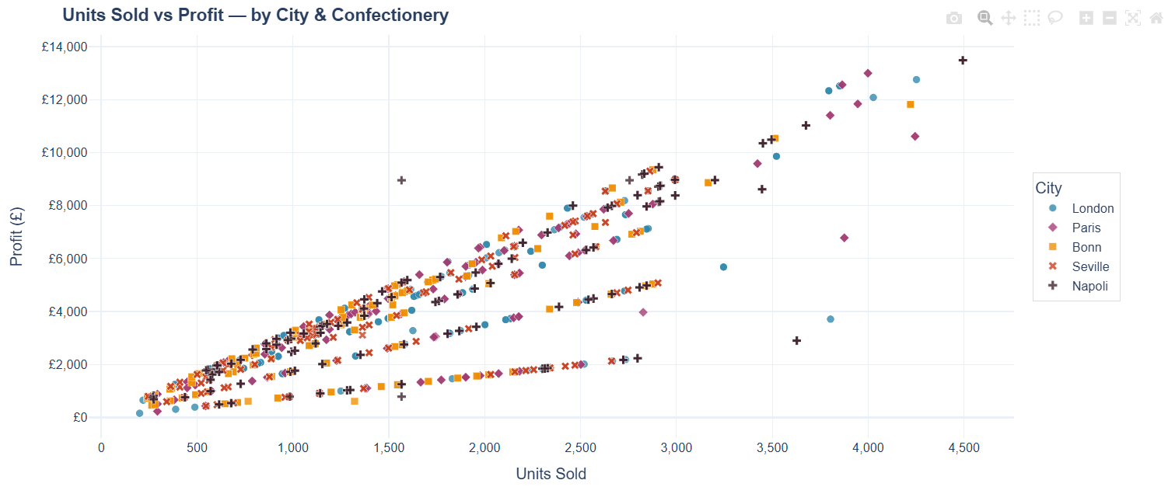
Figure 2.4.6: Units sold vs profit (scatter)

Chart 7: Revenue treemap
The treemap displays a rectangular arrangement of the same city → confectionery hierarchy as the sunburst. This is the version I would include in a board pack since treemaps are simpler to read for ranking than radial charts. The most obvious visual indication of the concentration risk in London is the enormous Caramel rectangle.
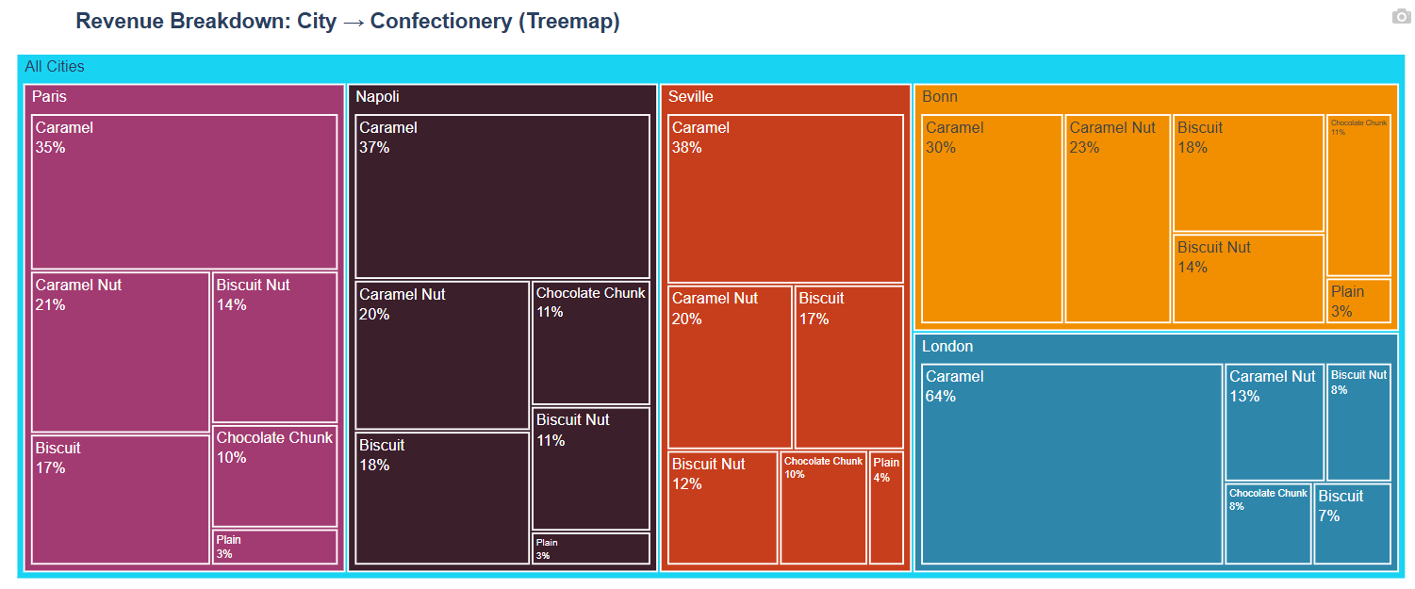
Figure 2.4.7: Revenue treemap, City to Confectionery

Chart 8: Revenue Sankey flow
With link width proportionate to revenue, the Sankey diagram depicts the movement of revenue from cities (left nodes) to confectionary products (right nodes). During a presentation, clicking a link locks the spotlight, which is helpful for displaying a single city → product flow. Out of the eight charts, this one has the most "story" content.
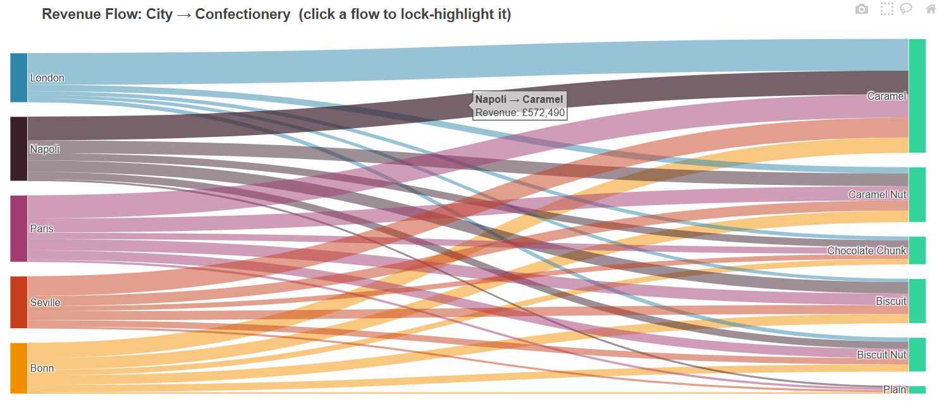
Figure 2.4.8: Revenue Sankey flow, City to Confectionery

The dashboard
I created a single HTML dashboard by combining the eight charts. The report title and student information are contained in the header. A global filter bar with three dropdowns (city, confectionery, and year) and a reset button is located beneath that. Beneath the filters are six KPI tiles that are updated in real time: Total Revenue, Total Profit, Profit Margin, Top City, Top Product, and Active Cities.
The charts are arranged in a distinct hierarchy beneath the KPI tiles. Because it provides the spatial context, the geo map is at the top. The full-width treemap is positioned next to the sunburst and radar, followed by the scatter and margin bar chart, the cost heatmap, and the Sankey flow. Every transaction is listed in a searchable, paginated table at the bottom for those who wish to export a slice or confirm a figure. The entire page is responsive and functions on both a 27-inch display and a mobile screen.
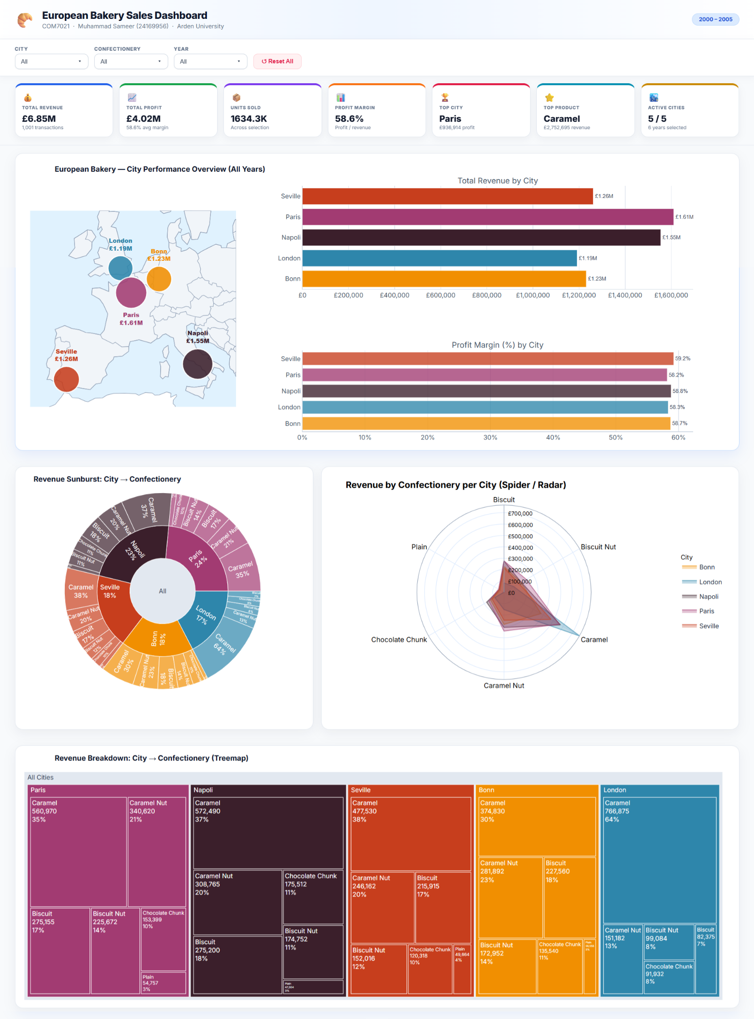
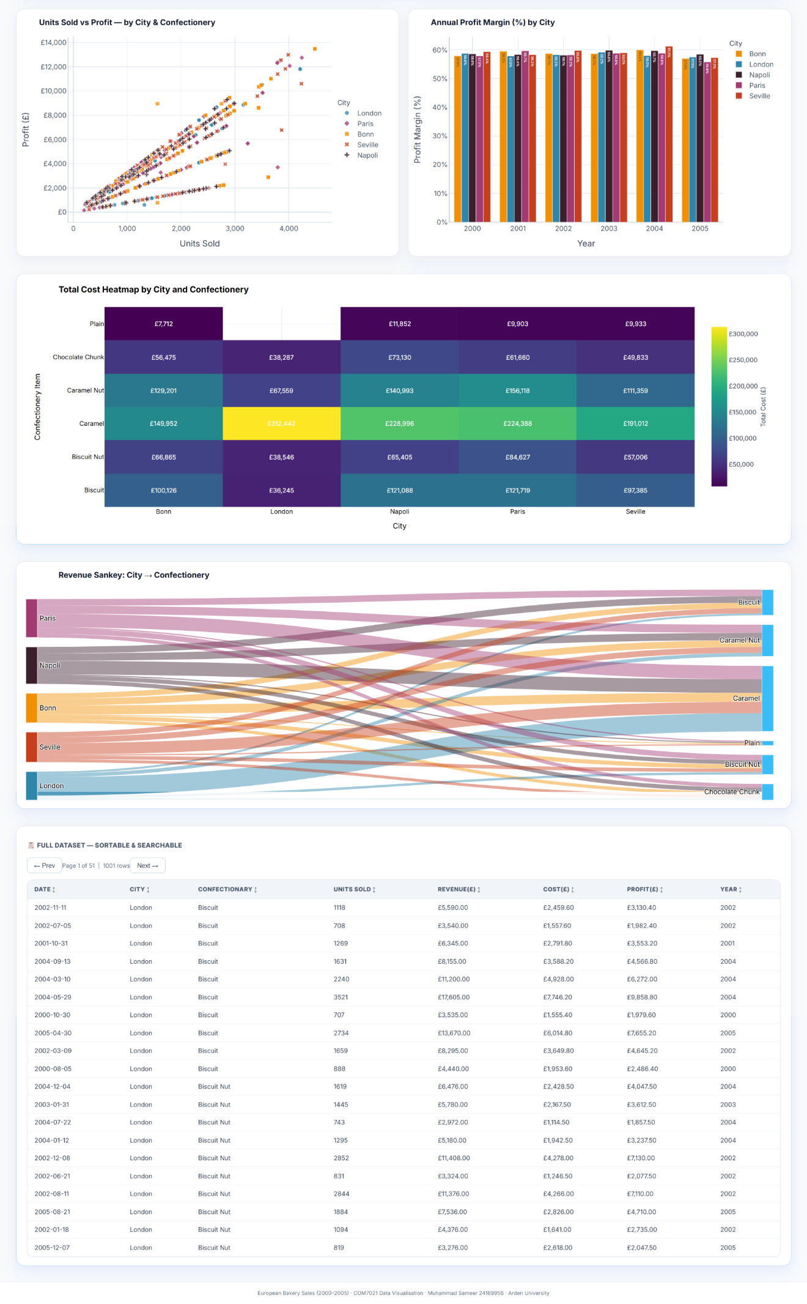

What the data tells us
The main response to the board's query is that no city ought to be shut down. The lowest-performing city, London, nonetheless generates about £700,000 in profit over a six-year period, and every city has a strong margin (Chart 5). Based on a misinterpretation of the statistics, closing London would cost £700,000.
The findings on the product side are more beneficial. Plain generates 0 pounds of profit in London and only 3.7% of total earnings (Table 2.6). In every other city, it is also the smallest seller. The board ought to think about reformulating or eliminating Plain. London's 64% Caramel concentration is also worth looking into because London is vulnerable if the recipe is altered or if a rival undercuts on it.

Confectionary | Biscuit | Biscuit Nut | Caramel | Caramel Nut | Chocolate Chunk | Plain | Total
Bonn | 127434 | 108095 | 224928 | 152692 | 79065 | 30846 | 723060
London | 46130 | 61928 | 451486 | 81890 | 53627 | 0 | 695061
Napoli | 154112 | 109220 | 343494 | 166628 | 102382 | 37843 | 913679
Paris | 154060 | 141045 | 336582 | 179290 | 86324 | 39613 | 936914
Seville | 123945 | 95010 | 286518 | 131606 | 70186 | 39731 | 746996
Total across all 5 cities |  |  |  | 4,015,710
Table 2.6: Profit matrix: City × Confectionery (£)

Task 2: A Critical Reflection

Justification of chart choices
Every chart had a corresponding question. Because projecting cities on a shared spatial frame is one of the most dependable encodings for location data and enables a board member to quickly identify the pattern, the geo map provides an answer to the question "where" (Midway, 2020). I utilised both a sunburst and a treemap for the part-of-whole question. In controlled user research comparing the two, Woodburn, Yang, and Marriott (2019) discovered that while sunburst charts were initially favoured for their aesthetic appeal but declined when nodes got smaller, treemaps performed slower and were less accurate on hierarchy understanding tasks. (Woodburn, et al., 2019).
I purposefully preserved both because they provide the same response for various audiences: treemap for direct ranking, sunburst for the one-glance summary. For a matrix query (product × year), the heatmap is the best option, and I carefully considered the color. I utilized a perceptually consistent Virdis scale rather than a rainbow palette because (Christen , et al., 2021) demonstrated that color can influence even expert decisions. As a chart type, the radar is more controversial. Rather than using it to read off exact values, one of the few tasks where radar charts do better than bars, I merely used it to display the shape of each city's product mix (Midway, 2020).
The Sankey was selected as a 'flow' pattern in the meaning described by (Bach, et al., 2023) in their dashboard design pattern library, the scatter provides an answer to a relationship query (units vs. profit); and the bar provides a direct comparison (margin per year). Each graphic is mapped to a question, an audience, and a strength in Table 3.1. The overall combination of eight visualizations is intentional, even beyond the chart-by-chart reasoning. Dashboards are categorised by audience and interaction level by (Alper, et al., 2019), and the board's mix of technical and non-technical members suggests a hybrid layout: richer analytical types (Sankey, radar, scatter) for the detail layer and simple high-level chart types (geo map, treemap, bar) for quick reading. This led to the decision to retain all eight instead of reducing them to three or four. In the first minute of a discussion, a board pack with only detail charts becomes difficult to scan, while one with only summary tiles loses the underlying evidence.

Chart | Question it answers | Best for | Audience
Geo map + KPI box | Where are the stores? | Spatial context | Whole board
Sunburst | What share does each city / product hold? | Hierarchy | Mixed
Cost heatmap | Where do costs concentrate? | Matrix view | Finance
Radar | What is each city's product mix shape? | Shape comparison | Strategy
Margin bar | Are margins consistent across years? | Direct comparison | Whole board
Scatter | Do more units mean more profit? | Relationship | Analyst
Treemap | Profit ranking by city / product | Ranking | Mixed
Sankey | Revenue flow city to product | Flow | Mixed
Table 3.1: Each chart and what I used it for

Designing the dashboard for a mixed audience
According to (Alper, et al., 2019) and (Bach, et al., 2023), the dashboard style places the most significant figures at the top, the visual proof in the center, and the supporting details at the bottom. In five seconds, the KPI tiles provide an answer to the board's query. The eight charts provide the analyst layer. For those who wish to confirm a number, the searchable raw data table is located at the bottom. The usage of colour is limited. A board member can follow London's contribution from the map to the treemap without having to repeatedly memorise the legend because each city has a single, fixed hue across all eight charts. In accordance with the chart-selection standards for business intelligence dashboards, animations are disabled and 3D is avoided (Orlovskyi & Kopp , 2020).

Strengths and limitations of the approach
Before deciding on this set, I thought about and rejected a few options. Although it lost the radar's quick shape comparison, a stacked bar chart of revenue by city would have more clearly displayed product mix. Because the data is noisy at the month level, a line chart of monthly profit per city was explored but ultimately discarded. The Tableau view now includes a clearer trend that was obtained using quarterly aggregation. Because angle is more difficult to compare than area (Midway, 2020), and the treemap and sunburst already cover that hierarchy more understandably, a pie chart for product share was completely rejected.
What worked: Instead of tabbing through eight different views, the global filter bar at the top updates every chart simultaneously, which feels much more seamless. About 2.5% of the data that would have been lost or altered was recovered by the cleaning process (typo correction and missing-value imputation). Every time a filter is changed, the KPI tiles refresh, providing the board with real-time responses while they investigate.
What didn't: the Sankey becomes visually distracting when thirty links are displayed at once, and it isn't truly helpful until you click a flow to lock the highlight. It is difficult to distinguish between Paris and Napoli without zooming in because their radar polygons nearly overlap. Although colour is helpful, some cities in the centre cluster cover one another in the scatter plot of 1,001 points.

Recommendations for the board
The research yields five recommendations (Table 3.4). First, the evidence does not support the decision to close any stores. Second, eliminate or reformulate the Plain product, which accounts for $0 in London and 3.7% of total earnings. Third, investigate the high concentration of caramel in London before it becomes a single point of failure. Fourth, examine the product mix of the top two cities, Paris and Napoli, and adapt what works there to London and Bonn. Fifth, incorporate city-specific quarterly margin tracking so that any decline below the 57% floor initiates an early review.
A few more inputs would make the recommendations more precise. Advertising-driven sales and organic shop performance could be distinguished with the aid of marketing expenditure per city. Rather than a structural taste preference, London's predominance of caramel might be the product of a single dominant campaign. I could determine whether London's low profit base is caused by fewer consumers or lower average baskets by using customer-level data (transaction-level loyalty, basket size, repeat rate). Instead of using raw earnings as a comparison, headcount and opening hours would assist measure store productivity. The board might evaluate the Caramel risk in the event of a price war, which is presently just a theory, by adding a competitor pricing feed.
Action | Why | Risk if ignored
Keep all five stores open | All cities profitable; lowest still earns £695k over six years | Lose a £700k profit stream on a misread
Drop or reformulate "Plain" | Generates 3.7% of profit; zero sales in London | Drag on shelf space and inventory cost
Investigate London's Caramel concentration | Caramel is 64% of London's revenue | Single-product exposure if taste shifts
Replicate Paris / Napoli playbook in Bonn and London | Top performers have the most balanced mix | Lower-volume sites stay flat
Track quarterly margin per city | All cities sit at 57%–60%; need early warning | Slow detection of margin decline
Table 3.4: Recommendations for the board

Tableau as a Comparative Dashboard

Why I also built a Tableau version
The Tableau work is supplemental and not the deliverable, as the brief makes it clear that Python is the necessary technology. I constructed it for two purposes. Initially, I wanted to demonstrate that I could use a different tool on the same data and still get a consistent result. Second, I wanted to evaluate how five cities and the same six product columns are handled by a drag-and-drop tool, particularly regarding uncleaned data.
Creating the same dataset twice also made me take my time and choose which chart to use instead of relying solely on the first tool. It provided me with a standard by which to measure the Plotly work. A gap in the Plotly dashboard would be indicated if the Tableau view showed a pattern that I had overlooked in Python.

How Tableau differs from the Python dashboard
The six Tableau tiles are as follows: a horizontal bar representing the total profit by European city; a multi-line chart representing the quarterly profit trend per city; a pie chart representing the revenue share by confectionery; a treemap representing the profit distribution by city and product; a stacked column representing the annual revenue breakdown by city; and a profit heatmap of city by type of confectionery. The most helpful addition was the quarterly line chart. I had aggregated to year in Plotly since the chart was overloaded by too many month markers, however Tableau's quarterly bin improved the visibility of seasonality. In most years, Napoli's earnings decrease significantly in the first quarter, something I had overlooked in the first Python work.
The total profit by city, quarterly profit trend, revenue share by confectionery, profit distribution by city and product, annual revenue breakdown, and a profit heatmap by city to confectionery are all six tiles rather than eight on the Tableau dashboard. Tableau's one-click date binning made it simpler to create the quarterly trend than Plotly. The color scale automatically adjusts to the data range, and the heatmap renders smoothly. The drawback is that Tableau displays "Chocolate Chunk" and "Caramel Nut" as distinct columns since it used the raw Excel data without my cleaning process. For the same reason, the visual numbers deviate significantly from the Python ones, which serve as a helpful example of why cleaning is important before any visualization.
The handling of typos was one of Tableau's drawbacks. Because "Choclate Chunk" and "Chocolate Chunk" remained separate slices on the pie without a cleaning step, London's Caramel domination appeared somewhat less intense than it actually is. This lesson was helpful. The choice of tool does not shield against the fact that a polished dashboard based on uncleaned data is less accurate than a rough one based on clean data. Tableau's strengths were built-in date intelligence and speed to first chart, while Plotly's had style control.
The Tableau dashboard is accessible at: European_Bakery_Dashboard_COM7021
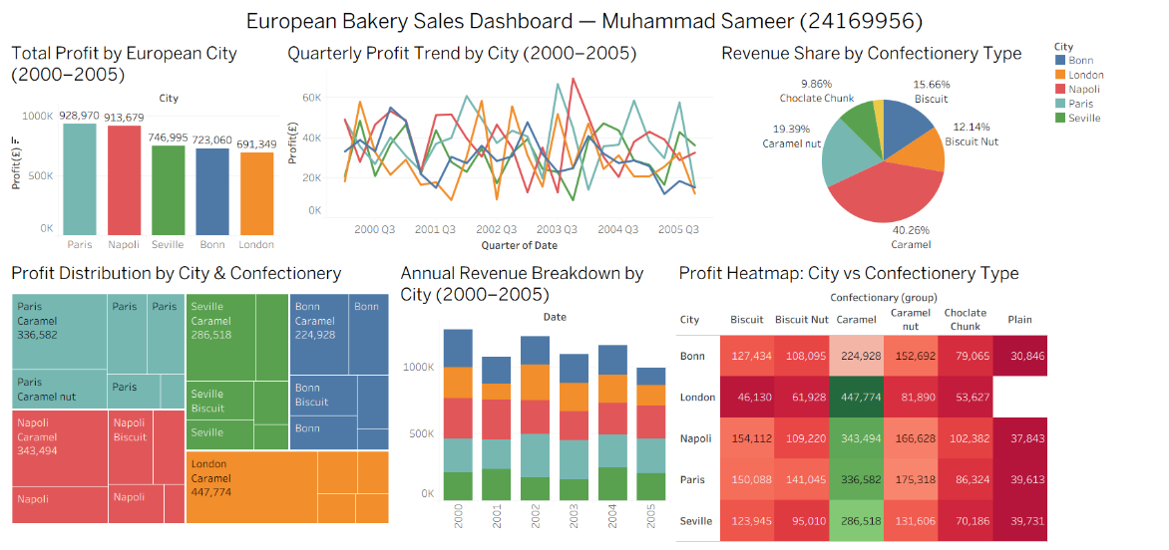
Figure 4.2 European_Bakery_Dashboard_COM7021

Conclusion
The inquiry yielded a definitive response. Based on the available data, none of European Bakery's five stores should be shuttered because they are all profitable on margin (between 57% and 60% over the course of six years). Paris and Napoli account for 46% of the overall earnings, while Caramel and Caramel Nut together provide 58% of the whole profit. The plain product, which accounts for 3.7% of total earnings and nothing in London, is the data's weakest point. London's high reliance on caramel, which accounts for 64% of its revenue and is a concentration concern needing a separate examination, is the next weakest area.
Eight charts and a live KPI block are pulled into a single HTML page by the Python dashboard, which also features city, product, and year filters that refresh everything simultaneously. The Tableau dashboard serves as a cross-check and is a condensed, lighter-touch version of the same image.
The data itself is the analysis's primary constraint. Although the file does not include marketing expenditure, manpower, opening hours, or specific seasonality, six years is a helpful window. If customer-level data is available, further work would divide clients, incorporate those factors, and provide a quarterly prediction.
There are three limitations that should be noted. First, while six years of data is sufficient to identify structural patterns, it is insufficient to confidently simulate multi-cycle seasonality. Second, I am unable to connect the results to the clients who initiated those transactions because the file is profit-only on a transaction basis. Third, the suggestions are predicated on the idea that patterns from 2000 to 2005 persist, which the board would have to verify against a more recent trading year. The next practical step is to develop a quarterly forecast model on top of the current dashboard, add the marketing and customer fields outlined in Section 3.4, and extend the dataset by at least one full trading year.

References
Alper, S. et al., 2019. What Do We Talk About When We Talk About Dashboards?. IEEE Transactions on Visualization and Computer Graphics, 25(1), pp. 682-692.
Bach, B. et al., 2023. Dashboard Design Patterns. IEEE Transactions on Visualization and Computer Graphics, Issue 1, pp. 342-352.
Christen , M., Brugger , P., Fabrikant , S. I. & van den Berg, R., 2021. Susceptibility of domain experts to color manipulation indicate a need for design principles in data visualization. PLOS ONE, 16(2), p. e0246479.
Midway, S. R., 2020. Principles of Effective Data Visualization. Patterns, 1(9), p. 10141.
Orlovskyi , D. & Kopp , A., 2020. A Business Intelligence Dashboard Design Approach to Improve Data Analytics and Decision Making. Kyiv, Ukraine, CEUR-WS.org, pp. 48-59.
Woodburn, L., Yang, Y. & Marriott, K., 2019. Interactive Visualisation of Hierarchical Quantitative Data: An Evaluation. Vancouver, BC, Canada, IEEE, pp. 96-100.

Appendices
GitHub Link: European Bakery Sales Interactive Dashboard
Libraries:
- Pandas
- Numpy
- Plotly.express
- Plotly.graph
- Json
- Plotly.io
- IPython.display
Environment: Google Colab
Folder Structure:
